Composition in Java
The composition is another form of aggregation which is considered as the restricted form of Association.
In this type of association, the entities are completely dependent on each other, unlike the aggregation. Composition allows for one-to-many relationships between objects.
It represents a part-of relationship between two objects. One entity cannot exist without the other.
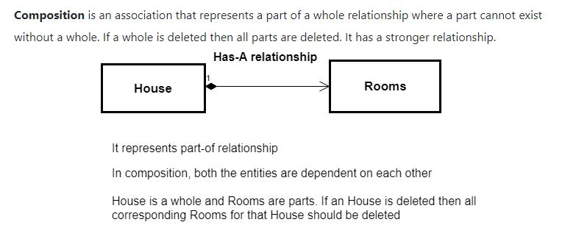

package p1;
class Job
{
private String role;
private long salary;
private int id;
public String getRole() {
return role;
}
public void setRole(String role) {
this.role = role;
}
public long getSalary() {
return salary;
}
public void setSalary(long salary) {
this.salary = salary;
}

public int getId() {
return id;
}
public void setId(int id) {
this.id = id;
}

public String toString() {
return String.format("ID=%d%nRole=%s%n", getID(),getRole());
}
}

class Person {

//composition has-a relationship
private Job j; //Classname reference;
//inside the constructor creat A OBJECT ,TO GET THE SALARY FOR COMPOSITION I MUST TO CREATE AN OBJECT INSIDE THE CONSTRUCTOR
public Person(){
this.j=new Job();
j.setSalary(1000L);
}

public String toString() {
return String.format("Salary=%d",job.getSalary());
}
}
public class TestPerson {
public static void main(String[] args)
{

Job j = new Job();
j.setId(10);
j.setRole("Fresher");

Person person = new Person();

System.out.println(j);
System.out.println(person);

}
}

package composition;

class Birthday
{
int date;
int month;
int year;

Birthday(int date,int month,int year)
{
this.date=date;
this.month=month;
this.year=year;
}

public void printbirthday()
{
System.out.println("Birthday"+date+"/"+month+"/"+year);
}
}
class Person
{
String name;
Birthday bday;

Person(String name,Birthday bday)
{
this.name=name;
this.bday=bday;

}

public void print()
{
System.out.println("name"+name);
bday.printbirthday();
}
}

public class Main
{
public static void main(String args[])
{
Birthday bday=new Birthday(1,1,1998);
Person per=new Person("raj",bday);
per.print();
}
}

